Unit #: 1
Unit Name: Problem solving fundamentals
Topic: Introduction to GCC, Program Structure, C Programming Environment, Errors in C program

Course objectives:
The objective(s) of this course is to make students
CObj1: Acquire knowledge on how to solve relevant and logical problems using computing machine
CObj2: Map algorithmic solutions to relevant features of C programming language constructs
CObj3: Gain knowledge about C constructs and it's associated eco-system
CObj4: Appreciate and gain knowledge about the issues with C Standards and it's respective behaviors
CObj5: Get insights about testing and debugging C Programs

Course outcomes:
At the end of the course, the student will be able to
CO1: Understand and apply algorithmic solutions to counting problems using appropriate C Constructs
CO2: Understand, analyse and apply text processing and string manipulation methods using C Arrays, Pointers and functions
CO3: Understand prioritized scheduling and implement the same using C structures
CO4: Understand and apply sorting techniques using advanced C contructs
CO5: Understand and evaluate portable programming techniques using preprocessor directives and conditional compilation of C Programs

Introduction to GCC
The original author of the GNU C Compiler is Richard Stallman, the founder of the GNU Project. GNU stands for GNU's not Unix. The GNU Project was started in 1984 to create a complete Unix-like operating system as free software, in order to promote freedom and cooperation among computer users and programmers. The first release of gcc was made in 1987, as the first portable ANSI C optimizing compiler released as free software. A major revision of the compiler came with the 2.0 series in 1992, which added the ability to compile C++. The acronym gcc is now used to refer to the “GNU Compiler Collection”
GCC has been extended to support many additional languages, including Fortran, ADA, Java and Objective-C. Its development is guided by the gcc Steering Committee, a group composed of representatives from gcc user communities in industry, research and academia

Features of GCC:
- A portable compiler, it runs on most platforms available today, and can produce output for many types of processors
- Supports microcontrollers, DSPs and 64-bit CPUs
- It is not only a native compiler, it can also cross-compile any program, producing executable files for a different system from the one used by gcc itself.
- Allows software to be compiled for embedded systems
- Written in C with a strong focus on portability, and can compile itself, so it can be adapted to new systems easily
- It has multiple language frontends, for parsing different languages
- It can compile or cross-compile programs in each language, for any architecture Example: Can compile an ADA program for a microcontroller or a C program for a supercomputer
- It has a modular design, allowing support for new languages and architectures to be added.
- It is free software, distributed under the GNU General Public License (GNU GPL), which means we have the freedom to use and to modify gcc, as with all GNU software.
- gcc users have the freedom to share any enhancements and also make use of enhancements to gcc developed by others.

Installation of gcc on different Operating systems

Windows OS – Installation of gcc using Mingw.

https://www.youtube.com/watch?v=sXW2VLrQ3Bs

Linux /MAC OS – gcc available by default

Program Development Life Cycle [PDLC]
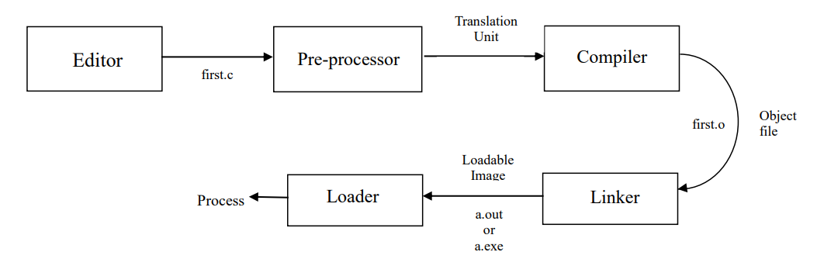
Phases involved in PDLC are Editing, Pre-processing, Compilation, Linking, Loading and execution.

The stages for a C program to become an executable are the following:

Editing:

We enter the program into the computer. This is called editing. We save the source program. Let us create first.c
$ gedit first.c // press enter key #include <stdio.h>
int main()

{ // This is a comment

//Helps to understand the code Used for readability printf(“Hello Friends”);
return 0;
}// Save this code in first.c

Pre-Processing:

In this stage, the following tasks are done:

  - Macro substitution–To be discussed in detail in Unit-5

  - Comments are stripped off


  - Expansion of the included files

The output is called a translation unit or translation.

To understand Pre-processing better, compile the above ‘first.c’ program using flag -E, which will print the pre-processed output to stdout.
$ gcc -E first.c// No file is created. Output of pre–processing on the standard output-terminal

......

# 846 "/usr/include/stdio.h" 3 4

# 886 "/usr/include/stdio.h" 3 4

extern void flockfile (FILE * stream) attribute (( nothrow )); extern int ftrylockfile (FILE * stream) attribute (( nothrow )) ; extern void funlockfile (FILE * stream) attribute (( nothrow ));
......

# 916 "/usr/include/stdio.h" 3 4

# 2 "first.c" int main()
{

printf("HelloFriends"); return0;
}

In the above output, you can see that the source file is now filled with lots of information, but still at the end of it we can see the lines of code written by us. Some of the observations are as below.

- Comment that we wrote in our original code is not there. This proves that all the comments are stripped off.
- The ‘#include’ is missing and instead of that we see whole lot of code in its place. So it is safe to conclude that stdio.h has been expanded and literally included in our source file.

Compiling

Compilation refers to the process of converting a program from the textual source code into machine code, the sequence of 1’s and 0’s used to control the central processing unit (CPU) of the computer. Machine code is then stored in a file known as an executable file. C programs can be compiled from a single source file or from multiple source files, and may use system libraries and header files. Compiler processes statements written in a particular programming language and converts them into machine language or "code" that a computer's processor uses. The translation is compiled. The output is called an object file. There may be more than one translation. So, we may get multiple object files. When compiling with ‘-c’, the compiler automatically creates an object file whose name is the same as the source file, but with ‘.o’ instead of the original extension
gcc -c first.c
This command does pre-processing and compiling. Output of this command is first.o ->

Object file.

- Linking

It is a computer program that takes one or more object files generated by a compiler and combine them into one, executable program. Computer programs are usually made up of multiple modules that span separate object files, each being a compiled computer program. This is the stage at which all the linking of function calls with their definitions are done. Till stage, gcc doesn’t know about the definition of functions like printf(). Until the compiler knows exactly where all of these functions are implemented, it simply uses a place-holder for the function call. The definition of printf() is resolved and the actual address of the function printf() is plugged in. We put together all these object files along with the predefined library routines by linking. The output is called as image or a loadable image with the name a.out [linux based] or a.exe[windows]
gcc first.o // Linking to itself
// If more than one object files are created after compilation, all must be mentioned with gcc and linked here to get one executable.

If a file with the same name[a.out/a,exe] as the executable file already exists in the current directory it will be overwritten. This can be avoided by using the gcc option -o. This is usually given as the last argument on the command line.
gcc first.o -o PESU // loadable image/Output file name is PESU

Executing the loadable image
Loader loads the image into the memory of the computer. This creates a process when command is issued to execute the code. We execute or run the process. We get some results. In ‘C’, we get what we deserve!
In windows,
a.exe and press enter OR
PESU and press enter
In Linux based systems,
./aout and press enter
./PESU and press enter

For interested students:
The following options of gcc are a good choice for finding problems in C and C++ programs.
gcc -ansi -pedantic -Wall -W -Wconversion -Wshadow -Wcast-qual -Wwrite-strings

Characteristics of a C program
- The language is case sensitive.
- The program is immune to indentation. ‘C’ follows the free format source code concept. The way of presentation of the program to the compiler has no effect on the logic of the program. However, we should properly indent the program so that the program becomes readable for humans. When you prepare a new dish, I am sure you will also consider how you present it.
- The program has a well-defined entry point. Every program has to have an entry point called main, which is the starting point of execution.
int main() // execution begins here
{ printf(“Hello Friends”);
return 0;
}
Think: Why the main function has the return type int? Why not something else ? Can we have something else? Is it a good practice?
- A program in ‘C’ normally has one or more pre-processor directives. These start with a symbol #. One of the directives is “include”.
    - #include <stdio.h>
The above line asks the translator to find the file whose name is stdio.h at some location in our file system and read and expand it at that point in the ‘C’ code.

- A program in ‘C’ has to have a function called main. It is invoked(called) from some external agency – like our shell. It is the duty of this function to tell the caller whether it succeeded or failed. So, by convention, main returns 0 on success and non-zero on failure. Refer to coding example_1 for more details.
- A block contains a number of statements. Each statement ends in a semicolon. This symbol ; plays the role of statement terminator

Program structure
Consists of different sections of which few are optional and other few are mandatory sections. Refer to the below diagram.
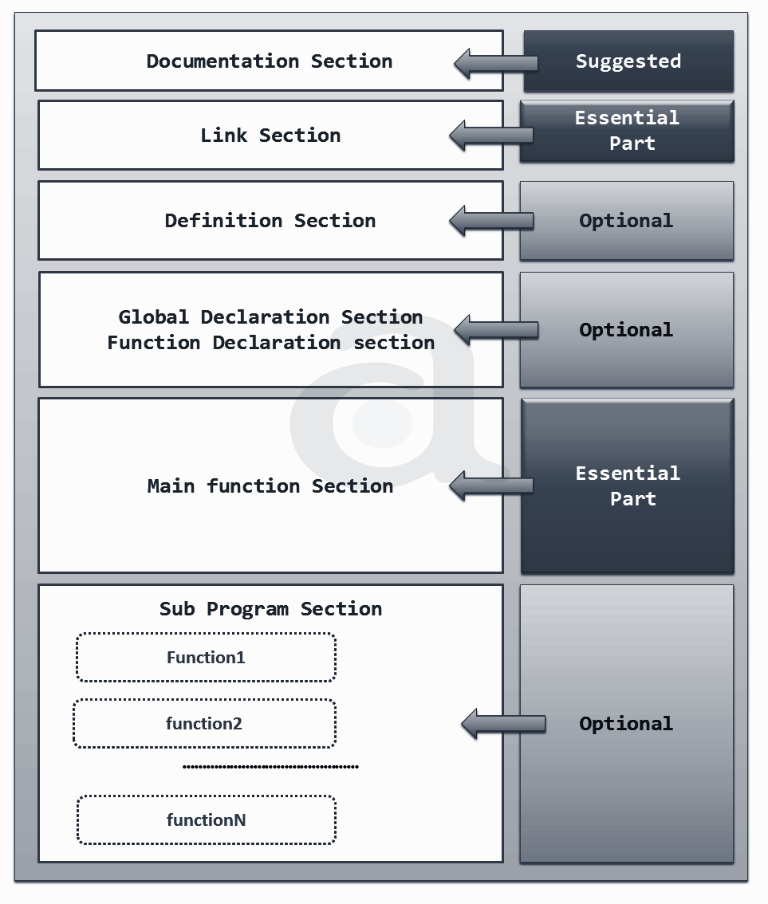

Documentation Section: Optional but always good to have. Usually contains the information about the code in terms of comments
// Single line comment
/* multi line/ block
Comments */

Link Section: Provides instructions to the compiler to link functions from the system library such as using the #include directive. Basically Header files that are required to execute a C program are included in the Link section.

Definition Section: This is the optional section
Contains the definitions of functions before calling the functions

Global Declaration Section: This is the optional section
Contains global variables declaration and function declaration(no body, only prototype/signature)

Main function Section: Every C program must have one main function section. Contains two parts: the declaration part and the executable part. Declaration part declares all the variables used in the executable part. Executable part: There is at least one statement in the executable part. These two parts must appear between the opening and closing braces. The program execution begins at the opening brace and ends at the closing brace. The closing brace of the main function is the logical end of the program. All statements in the declaration and executable part end with a semicolon.

Sub program section: Optional section and contains user defined functions. We will discuss in Unit – 2.

Coding example_1: // Importance of return value in main
int main() // this code is saved as main.c
{
printf(“welcome to main function in C”);
return 0;
}
Execute the above code using below steps:
gcc -c main.c // press enter - main.o gets created if no error
gcc main.o // press enter - executable gets created if no error
a.exe // prints welcome to main function in C

If someone wants to know whether the recently executed process is executed successfully or not, this return value is very helpful.
After you get the output, use below commands to know what the return value of recently executed process.
echo %ERRORLEVEL% // in windows
echo $? // in linux based systems

Must return 0 to represent the success[by convention 0 is success]. Modify the code as below.
int main() // this code is saved as main.c
{
printf(“welcome to main function in C”);
}
Repeat the same steps as mentioned in the first case, there is no way to get the success or failure info about the recently executed process. Results in some random value other than 0.

Coding example_2: // Compilation using different C Standards
__STDC_VERSION__: A macro defined in stdio.h
To understand better, use codes using –E option of GCC.
gcc -E
// file saved as first.c
int main()
{ printf("C standard is %d\n",__STDC_VERSION__);
return 0;
}
Preprocessing and Compilation using C99: gcc –std=c99 -c first.c
Linking remains the same: gcc first.o
Execute: a.exe OR ./a.out
Output: C standard is 199901

Preprocessing and Compilation using C11: gcc –std=c11 -c first.c
Linking remains the same: gcc first.o
Execute: a.exe OR ./a.out
Output: C standard is 201112

Preprocessing and Compilation using C89: gcc –std=c89 -c first.c
Results in Compile time Error as this macro is not available in C89 standard

Error(s) in C Code

Error is a mistake, the state or condition of being wrong in conduct or judgement, a measure of the estimated difference between the observed or calculated value of a quantity and its true value. Error is an illegal operation performed by the programmer which results in abnormal working of the program. Error is also known as bugs in the world of programming that may occur unwillingly which prevent the program to compile and run correctly as per the expectation of the programmer. We deal with four kinds of errors as of now.
Compile time Error
Link time Error
Run time Error
Logical Error

Compile time Error
Deviation from the rules of the Language or violating the rules of the language results in compile time Error. Whenever there is Compile Time Error, object file(.o file) will not be created. Hence linking is not possible. When the programmer does not follow the syntax of any programming language, then the compiler will throw the Syntax Error which are also compile time errors. Syntax Errors are easy to figure out because the compiler highlights the line of code that caused the error.

Coding Exampe_3:
#include<stdio.h>

int main()
{
printf("hello friends); //" missing at the end
printf("%d",12/2) // ; missing at the end of statement
return 0;
}

Link time Error
Errors encountered when the executable file of the code cannot be generated even though the code gets compiled successfully. This usually happens due to the mismatch between Function call and function definitions. When you compile the code, object file gets created. Sometimes with a warning. During linking, definition of Printf is not available in the included file. Hence Link time Error. No loadable object will be created due to this error. This Error is generated when a different object file is unable to link with the main object file.
Coding Exampe_4:
#include<stdio.h>
int main()
{ Printf("hello friends"); // P is capital
printf("%d",12/2);
return 0;
}

Run time Error
Errors that occur during the execution (or running) of a program are called Runtime Errors. These errors occur after the program has been compiled and linked successfully. When the code is compiled, object file(.o file) will be created. Then during linking, executable will be created. When you run a loadable image, code terminates throwing an error. Generally occurs due to some illegal operation performed in the program. Examples of some illegal operations that may produce runtime errors are: Dividing a number by zero, trying to open a file which is not created and lack of free memory space.
Coding Exampe_5:
#include<stdio.h>
int main()
{
printf("hello friends");
printf("%d",12/0); // Observe 12/0 printf("bye friends");
return 0;
}

Logical Error:

Even though the code seems error free, the output generated is different from the expected one. Logical error occurs when the code runs completely but the expected output is not same as the actual output.

Coding Example_6:
#include<stdio.h>
int main ()
{
printf("%d",12/21); //By Mistake entered 21
//instead of 2
return 0;
}

Warning(s) in C:
Warnings are diagnostic messages that report constructions which are not inherently erroneous but which are risky or suggest there may have been an error or crash in future. The compiler distinguishes between error messages, which prevent successful compilation, and warning messages which indicate possible problems but do not stop the program from compiling. It is very dangerous to develop a program without checking for compiler warnings. If there are any functions which are not used correctly they can cause the program to crash or produce incorrect results. Turning on the compiler warning option ‘-Wall’ for safety will catch many of the commonest errors which occur in c programming.

Why the warning must be enabled?
C and C++ compilers are notoriously bad at reporting some common programmer mistakes by default, such as:
- forgetting to initialise a variable
- forgetting to return a value from a function
- arguments in printf and scanf families not matching the format string
- a function is used without being declared beforehand (C only)
Most compilers understand options like -Wall, -Wpedantic and -Wextra. -Wall is essential and all the rest are recommended (note that, despite its name, -Wall only enables the most important warnings, not all of them). These options can be used separately or all together.

Error vs warning
Errors report problems that make it impossible to compile your program. GCC reports errors with the source file name and line number where the problem is apparent. Warnings report other unusual conditions in your code that may indicate a problem, although compilation can proceed.
Coding Example_7:
#include<stdio.h>
int main()
{
int a;
printf("enter the number\n");
scanf("%d",a);
printf("you entered %d\n",a);
return 0;
}
Without -wall option, there is no warning or error. But results in Runtime Error when the code is run using the executable.
The above code compilation using –Wall is as below. This creates the object file. But at runtime, it fails to execute
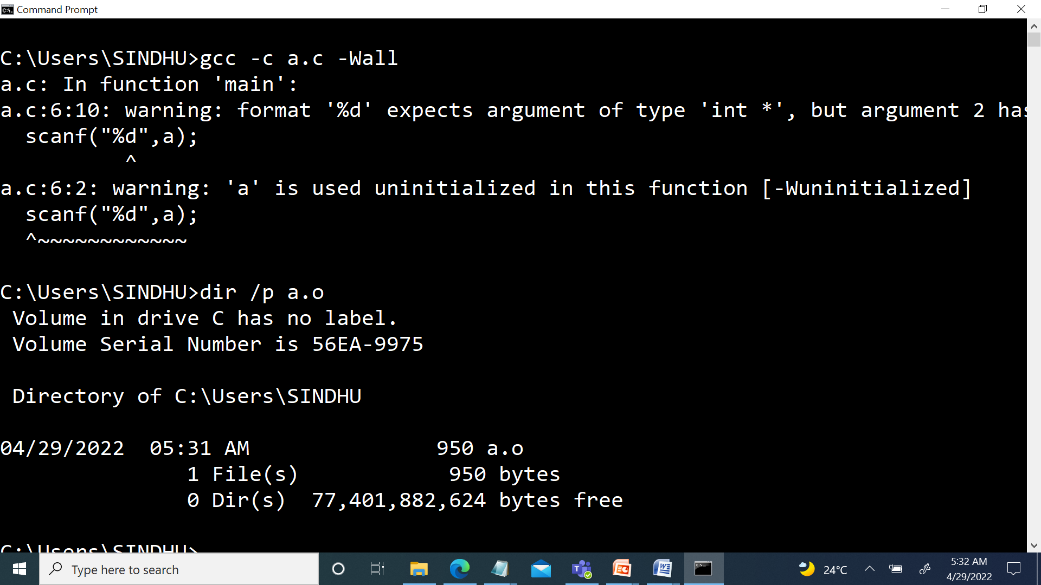
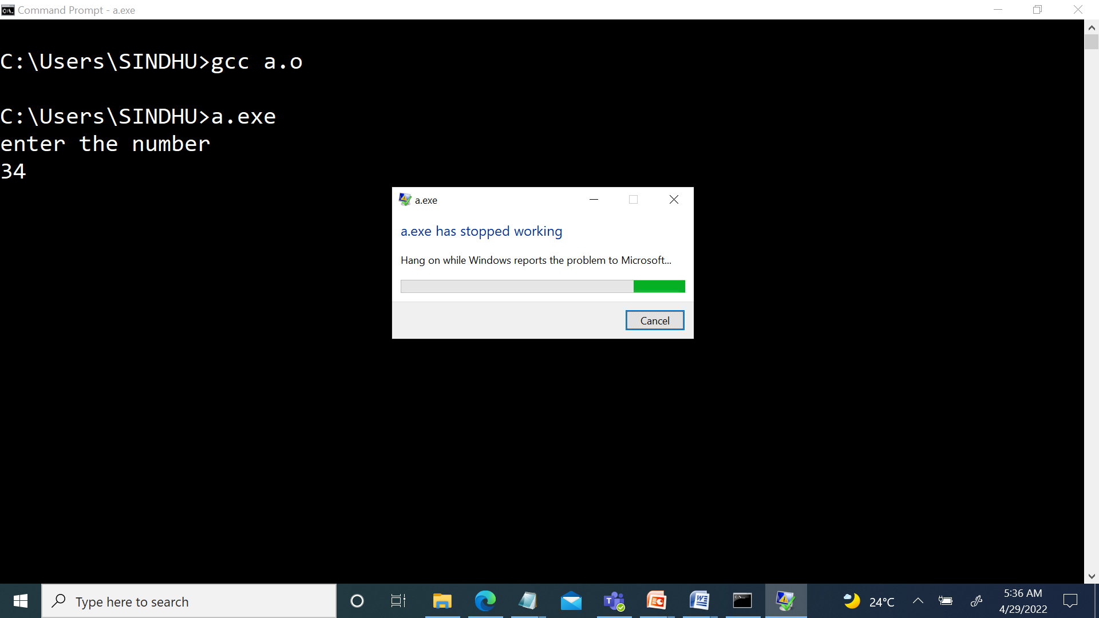
Happy Error Finding!!

